

Practical File Submission

Course Name: JavaScript Lab
Course Code: T-3013 / 0705210508
Submitted by
Preetish Notwani
24070521181
Batch: 2024-28
Semester - V
Section: C

Submitted to
Dr. Shreyas Rajendra Hole

Practical 1
Experiment Title: Demonstrate inline, internal, and external JavaScript; use console methods; create a webpage showing user info and a welcome message.
Software/Tools Required: VS Code , Web Browser
Experiment Program Code:
Demo html file:
<!DOCTYPE html>
<html>
<head>
<title>CSS and JavaScript Demonstration</title>

<!-- External CSS -->
<link rel="stylesheet" href="external.css">

<!-- Internal CSS -->
<style>
body{
text-align:center;
font-family:Arial, sans-serif;
}

h1{
color:darkblue;
}

.internal{
color:darkblue;
}

button{
padding:10px 20px;
font-size:20px;
background:#1f4e79;
color:white;
border:none;
border-radius:5px;
cursor:pointer;
}
</style>
</head>

<body>

<h1 class="internal">Welcome to Internal CSS</h1>

<h2>Name: Preetish Notwani</h2>
<h2>PRN: 24070421181</h2>

<!-- Inline CSS -->
<h1 style="color:green;">Welcome to Inline CSS</h1>

<h2>Name: Preetish Notwani</h2>
<h2>PRN: 240704211981</h2>

<!-- External CSS -->
<h1 class="external">Welcome to External CSS</h1>

<h2>Name: Preetish Notwani</h2>
<h2>PRN: 24070421181</h2>

<!-- Inline JavaScript -->
<button onclick="showMessage()">Click Me</button>

<h2 id="msg"></h2>

<!-- External JavaScript -->
<script src="script.js"></script>

</body>
</html>

Output:
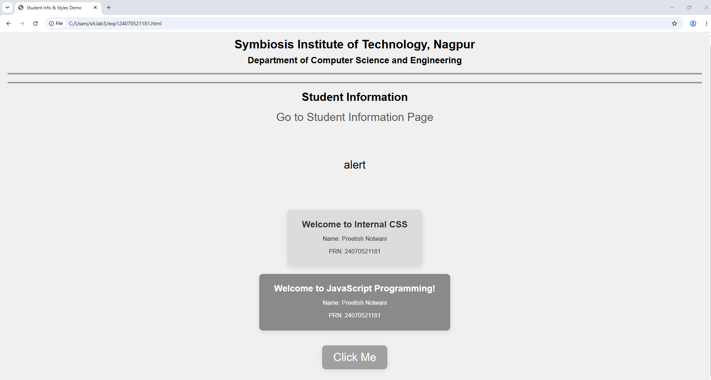

Case Study 01
Case Study Title:- Create a web page for college department and link the student information page with it and write a js program to display "Welcome to SIT Nagpur" in an alert box
Case Study Code:
Department file (HTML):-
<!DOCTYPE html>
<html>

<head>
<title>SIT Nagpur Department</title>

<style>
body {
background-color: rgb(176, 213, 216);
font-family: Arial, sans-serif;

display: flex;
justify-content: center;
align-items: center;
height: 100vh;
margin: 0;
}

.box {
background-color: white;
padding: 30px;
border: 2px solid #000;
border-radius: 10px;
text-align: center;
width: 400px;
}
</style>
</head>

<body>

<div class="box">
<h1>SIT Nagpur - Computer Science Department</h1>

<p>Welcome to our official SIT, Nagpur department page.</p>
<p>Preetish Notwani</p>
<p>PRN-24070521181</p>

<p>
<a href="student-info.html">Click here to view Student Info</a>
</p>
</div>

<script>
alert("Welcome to SIT Nagpur");
</script>

</body>

</html>

Output:
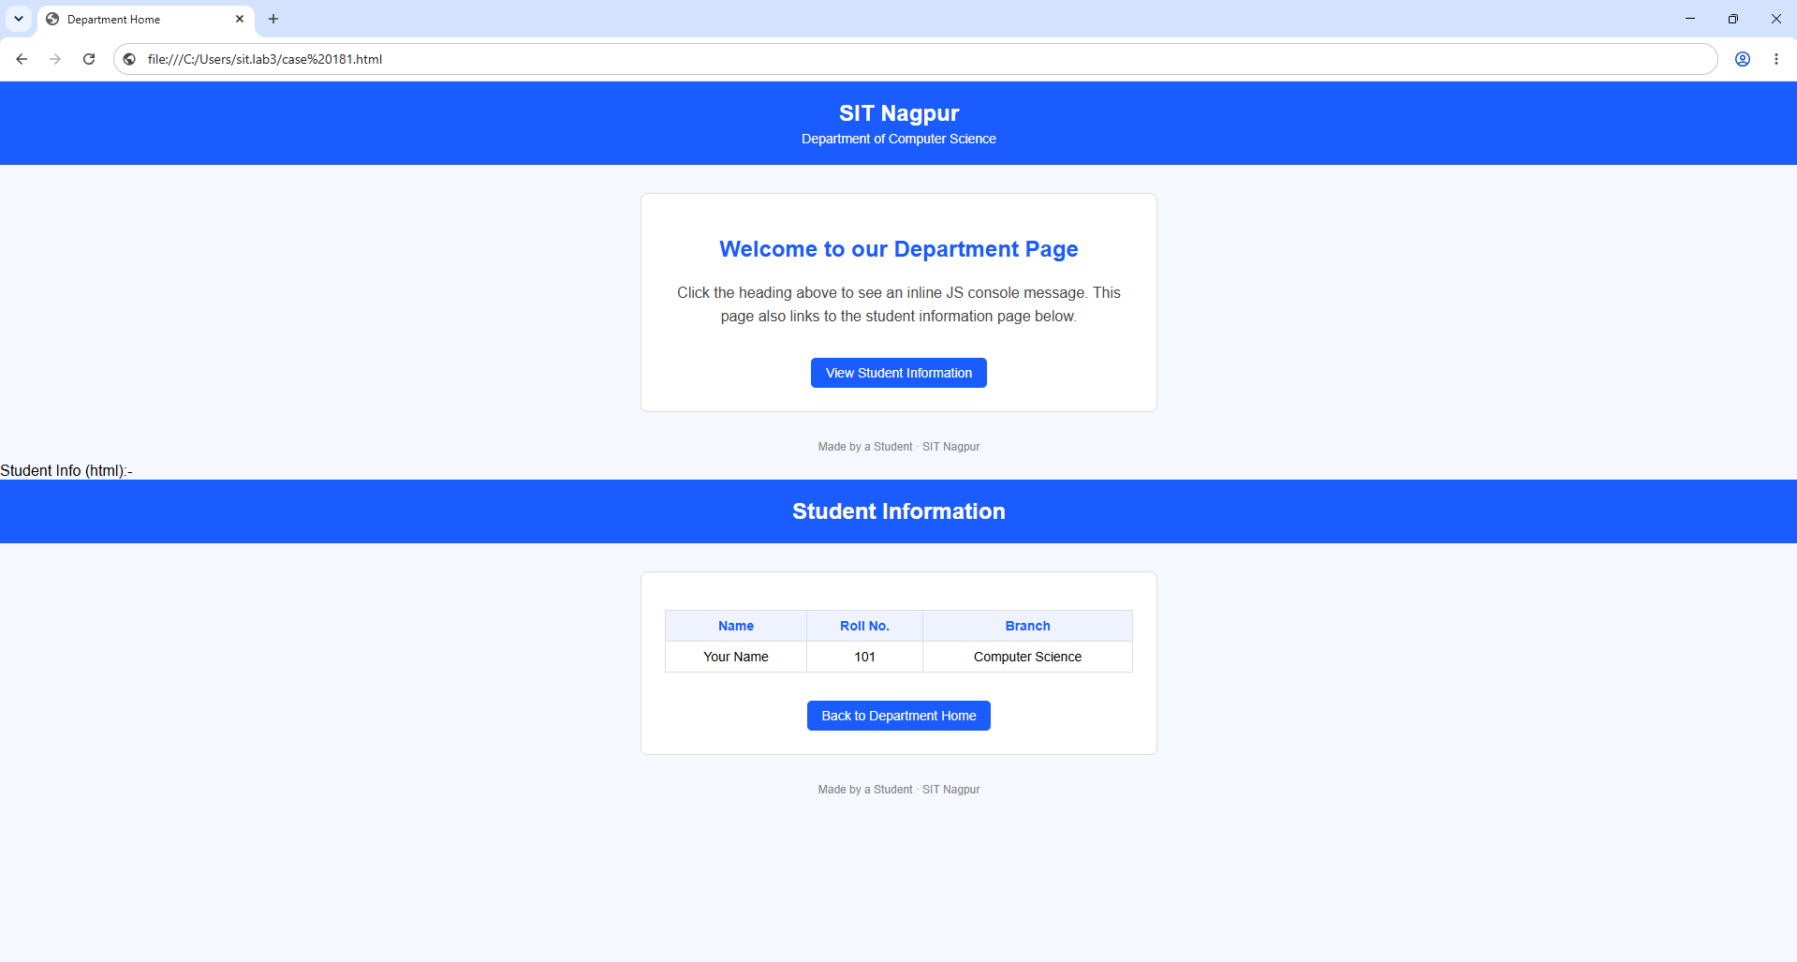

Result / Conclusion:-
Hence we have created a basic html page with javascript to show student information and and website login page.

Practical 02
Aim:- Use var, let, const, and demonstrate basic features like template literals and destructuring; build a billing calculator with user input.
Software/Tools Required: VS Code , Web Browser
Experiment program code:
Calculator.html:-
<!DOCTYPE html>
<html>

<head>
<title>Billing Calculator</title>
</head>

<body>

<h2>Billing Calculator</h2>

<script>

const GST = 0.18;

var customerName = prompt("Enter Customer Name: ");
var productName = prompt("Enter Product Name: ");

var quantity = Number(prompt("Enter quantity"));
let price = Number(prompt("Enter price per Item"));

let total = quantity * price;
let gstAmount = total * GST;
let finalBill = total + gstAmount;

const bill = {
customer: customerName,
product: productName,
quantity,
price,
total,
gstAmount,
finalBill
};

const {
customer,
product,
gstAmount: gst,
finalBill: amount
} = bill;

document.write("<h3>Billing Receipt</h3>");
document.write(`<p>Customer: ${customer}</p>`);
document.write(`<p>Product: ${product}</p>`);
document.write(`<p>Quantity: ${quantity}</p>`);
document.write(`<p>Price per Item: ₹${price}</p>`);
document.write(`<p>Total: ₹${total}</p>`);
document.write(`<p>GST (18%): ₹${gst.toFixed(2)}</p>`);
document.write(`<h3>Final Bill: ₹${amount.toFixed(2)}</h3>`);

</script>

</body>
</html>

Output:-
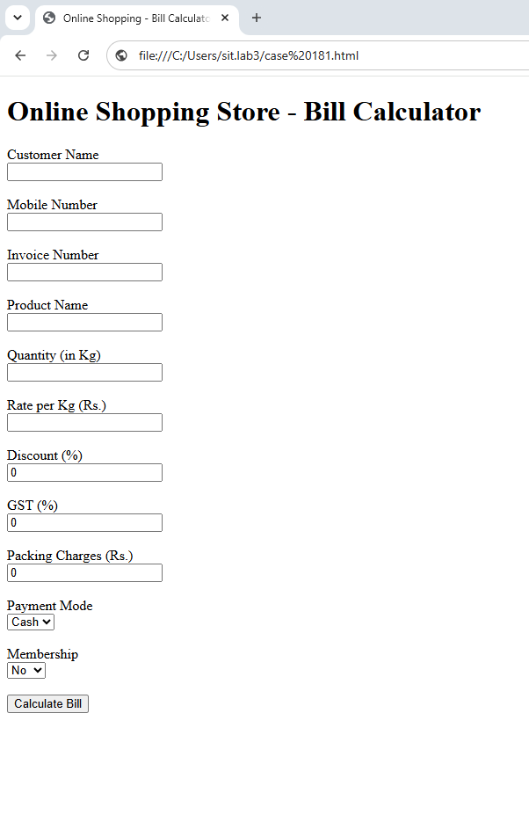

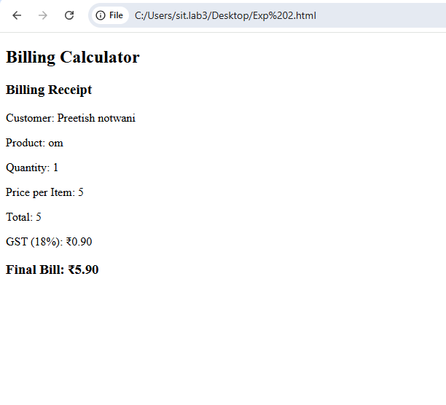

Case Study 02
Case Study Title:- Develop the webpage for an online shopping website with using HTML,CSS and HTML5 tags
Software/Tools Used:- VScode , Web Browser
Code:-
<!DOCTYPE html>
<html>
<head>
<title>Online Shopping Store - Bill Calculator</title>
</head>

<body>

<h1>Online Shopping Store - Bill Calculator</h1>

<form id="billForm">

<label>Customer Name</label><br>
<input type="text" id="customer" required><br><br>

<label>Mobile Number</label><br>
<input type="text" id="mobile" required><br><br>

<label>Invoice Number</label><br>
<input type="text" id="invoice" required><br><br>

<label>Product Name</label><br>
<input type="text" id="product" required><br><br>

<label>Quantity (in Kg)</label><br>
<input type="number" id="qty" required><br><br>

<label>Rate per Kg (Rs.)</label><br>
<input type="number" id="rate" required><br><br>

<label>Discount (%)</label><br>
<input type="number" id="discount" value="0"><br><br>

<label>GST (%)</label><br>
<input type="number" id="gst" value="18"><br><br>

<label>Packing Charges (Rs.)</label><br>
<input type="number" id="packing" value="0"><br><br>

<label>Payment Mode</label><br>
<select id="payment">
<option>Cash</option>
<option>Card</option>
<option>UPI</option>
</select>

<br><br>

<label>Membership</label><br>
<select id="member">
<option>No</option>
<option>Yes</option>
</select>

<br><br>

<input type="button" value="Calculate Bill" onclick="calculateBill()">

</form>

<hr>

<div id="result"></div>

<script>

function calculateBill()
{
let customer=document.getElementById("customer").value;
let mobile=document.getElementById("mobile").value;
let invoice=document.getElementById("invoice").value;
let product=document.getElementById("product").value;

let qty=parseFloat(document.getElementById("qty").value);
let rate=parseFloat(document.getElementById("rate").value);

let discount=parseFloat(document.getElementById("discount").value);
let gst=parseFloat(document.getElementById("gst").value);

let packing=parseFloat(document.getElementById("packing").value);

let payment=document.getElementById("payment").value;
let member=document.getElementById("member").value;

let subtotal=qty*rate;

let discountAmount=subtotal*discount/100;

let afterDiscount=subtotal-discountAmount;

let gstAmount=afterDiscount*gst/100;

let membershipDiscount=0;

if(member=="Yes")
{
membershipDiscount=afterDiscount*0.05;
}

let total=afterDiscount+gstAmount+packing-membershipDiscount;

document.getElementById("result").innerHTML=
`
<b>Customer:</b> ${customer} (${mobile})<br><br>

<b>Invoice No:</b> ${invoice}<br><br>

<b>Product:</b> ${product} (${qty} Kg)<br><br>

<b>Subtotal:</b> Rs. ${subtotal.toFixed(2)}<br><br>

<b>Discount:</b> Rs. ${discountAmount.toFixed(2)}<br><br>

<b>GST:</b> Rs. ${gstAmount.toFixed(2)}<br><br>

<b>Packing Charges:</b> Rs. ${packing.toFixed(2)}<br><br>

<b>Membership Discount:</b> Rs. ${membershipDiscount.toFixed(2)}<br><br>

<b>Payment Mode:</b> ${payment}<br><br>

<h3>Total Bill: Rs. ${total.toFixed(2)}</h3>
`;
}

</script>

</body>
</html>

Output:-

Practical 3
Aim:- Implement control structures and form validation; create a grading system based on user-entered marks.
Software/Tools Required: VS Code , Web Browser
Experiment program code:
Student Marks and grade:-
<!DOCTYPE html>
<html>

<head>
<title>Student Grade</title>
<style>
body {
background-color: #f4f6f9; /* Change this hex code to any color you like */
font-family: Arial, sans-serif; /* Optional: Makes the text look cleaner */
}
</style>
</head>

<body>

<h2>Student Grading System</h2>

<h3>Student Details</h3>
<p><b>Name:</b>Preetish Notwani</p>
<p><b>PRN:</b> 24070521181</p>

<hr>

<label>Enter Marks:</label>
<input type="number" id="marks">

<button onclick="checkGrade()">Submit</button>

<p id="result"></p>

<script>

function checkGrade() {

let marks = document.getElementById("marks").value;

// Form Validation
if (marks == "") {
document.getElementById("result").innerHTML =
"Please enter marks.";
return;
}

marks = Number(marks);

if (marks < 0 || marks > 100) {
document.getElementById("result").innerHTML =
"Marks should be between 0 and 100.";
return;
}

let grade = "";

// Control Structure (if-else)
if (marks >= 90) {
grade = "A+";
}
else if (marks >= 80) {
grade = "A";
}
else if (marks >= 70) {
grade = "B";
}
else if (marks >= 60) {
grade = "C";
}
else if (marks >= 50) {
grade = "D";
}
else {
grade = "Fail";
}

document.getElementById("result").innerHTML =
"<b>Name:</b> Preetish Notwani<br>" +
"<b>PRN:</b> 24070521181<br>" +
"<b>Marks:</b> " + marks + "<br>" +
"<b>Grade:</b> " + grade;
}

</script>
</body>

</html>
Output:-

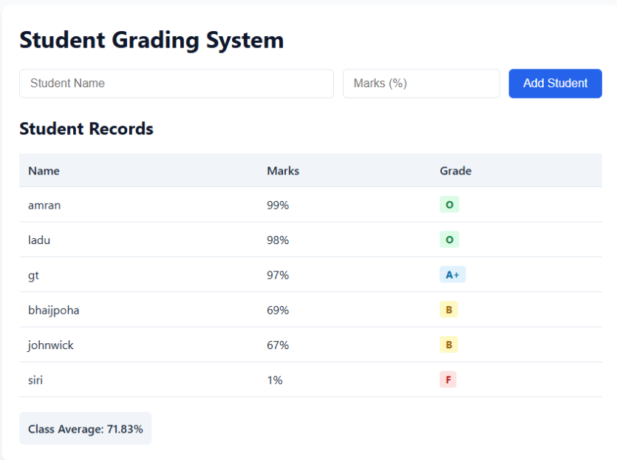

Case Study 03
Case Study Title:- Scholarship Eligibilty:
A college awards scholarship based on marks
Below 50:- Not eligible
50-69:- Bronze Scholarship
70-84:- Silver Scholarship
85-94:- Gold Scholarship
95-100:- Platinum Scholarship
Software/Tools Used:- VScode , Web Browser
Case Study Code:

<!DOCTYPE html>
<html>

<head>
<title>Scholarship Eligibility</title>

<style>
body {
font-family: Arial, sans-serif;
background-color: white;
text-align: center;
padding: 60px;
}

h2 {
color: #c21321af;
margin: 5px 0;
}

h3 {
margin-top: 30px;
margin-bottom: 10px;
}

input {
width: 220px;
padding: 10px;
font-size: 16px;
border: 1px solid #c0e61b;
border-radius: 4px;
outline: none;
}

button {
display: block;
margin: 18px auto 0;
padding: 10px 25px;
font-size: 16px;
background-color: #1a5cff;
color: white;
border: none;
border-radius: 4px;
cursor: pointer;
}

button:hover {
background-color: #0d3fb0;
}

#result {
margin-top: 25px;
font-size: 18px;
color: #444;
line-height: 1.5;
}
</style>
</head>

<body>

<h2>Preetish Notwani 24070521181</h2>
<h2>Scholarship Eligibility System</h2>

<h3>Enter marks:</h3>

<input type="number" id="marks">

<button onclick="checkScholarship()">Submit</button>

<p id="result"></p>

<script>

function checkScholarship() {

let marks = Number(document.getElementById("marks").value);

// Form Validation
if (document.getElementById("marks").value == "") {
alert("Please Enter Marks!");
return;
}

if (marks < 0 || marks > 100) {
alert("Enter marks between 0 and 100.");
return;
}

let scholarship = "";

if (marks >= 95) {
scholarship = "Platinum Scholarship";
}
else if (marks >= 85) {
scholarship = "Gold Scholarship";
}
else if (marks >= 70) {
scholarship = "Silver Scholarship";
}
else if (marks >= 50) {
scholarship = "Bronze Scholarship";
}
else {
scholarship = "Not Eligible";
}

document.getElementById("result").innerHTML =
"Marks = " + marks +
"<br>Scholarship = " + scholarship;

}

</script>

</body>

</html>

Output:-

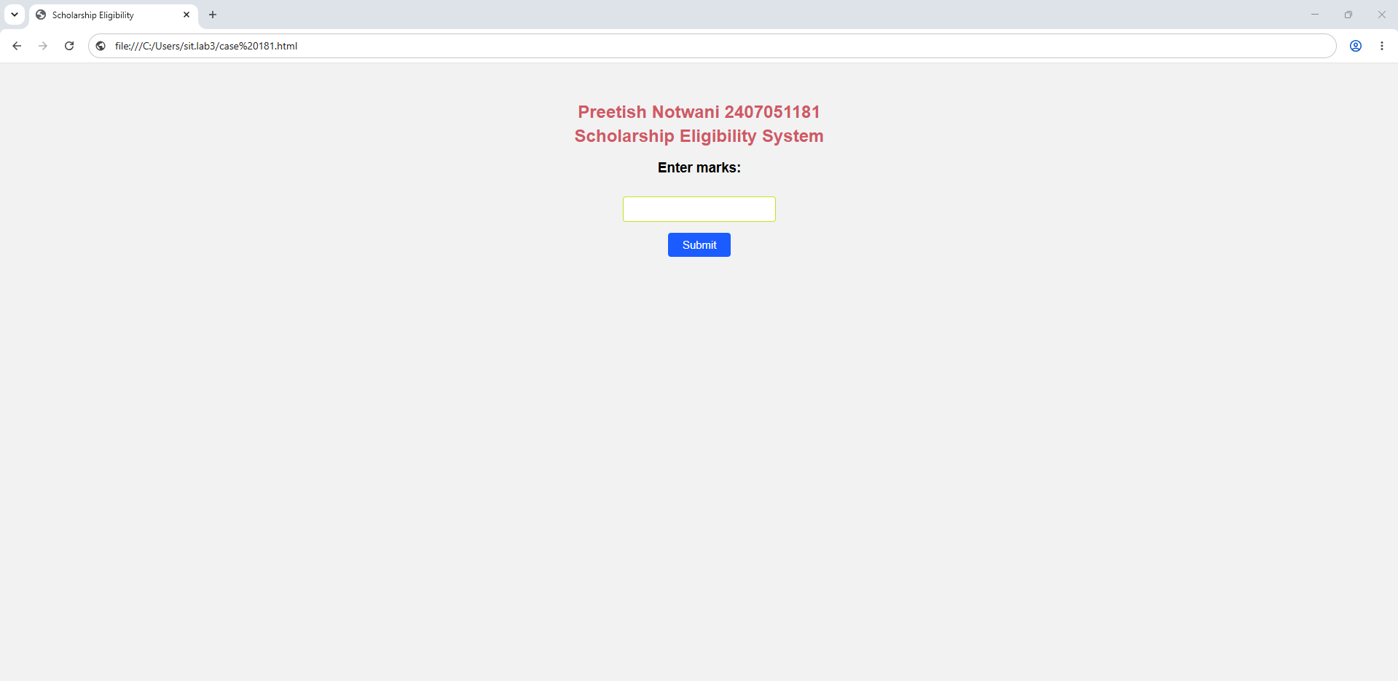

Practical 4
Aim:- Use function types ,scope , and closure; apply try catch ;build a palindrome checker
Software/Tools Required: VS Code , Web Browser
Experiment program code:
Palindrome checker:-

<!DOCTYPE html>
<html>

<head>
<title>Palindrome Checker</title>

<style>
body {
font-family: "Times New Roman", Times, serif;
margin: 16px;
}

h1 {
font-size: 54px;
font-weight: bold;
margin-bottom: 40px;
}

input {
width: 345px;
}

#result {
margin-top: 25px;
}
</style>
</head>

<body>

<h1>Palindrome Checker</h1>

<input type="text" id="userInput" value="civic">

<button onclick="checkPalindrome()">Check</button>

<p id="result"></p>

<script>

function checkPalindrome() {

let input = document.getElementById("userInput").value;

if (input == "") {
document.getElementById("result").innerHTML =
"Please enter a value.";
return;
}

let cleanStr = input.toLowerCase().replace(/[^a-z0-9]/g, "");

let reversedStr = cleanStr.split("").reverse().join("");

if (cleanStr === reversedStr) {
document.getElementById("result").innerHTML =
'"' + input + '" is a palindrome! (Reversed: ' + reversedStr + ')';
}
else {
document.getElementById("result").innerHTML =
'"' + input + '" is not a palindrome. (Reversed: ' + reversedStr + ')';
}

}

// Display the result automatically for "civic"
checkPalindrome();

</script>

</body>

</html>
Output:-
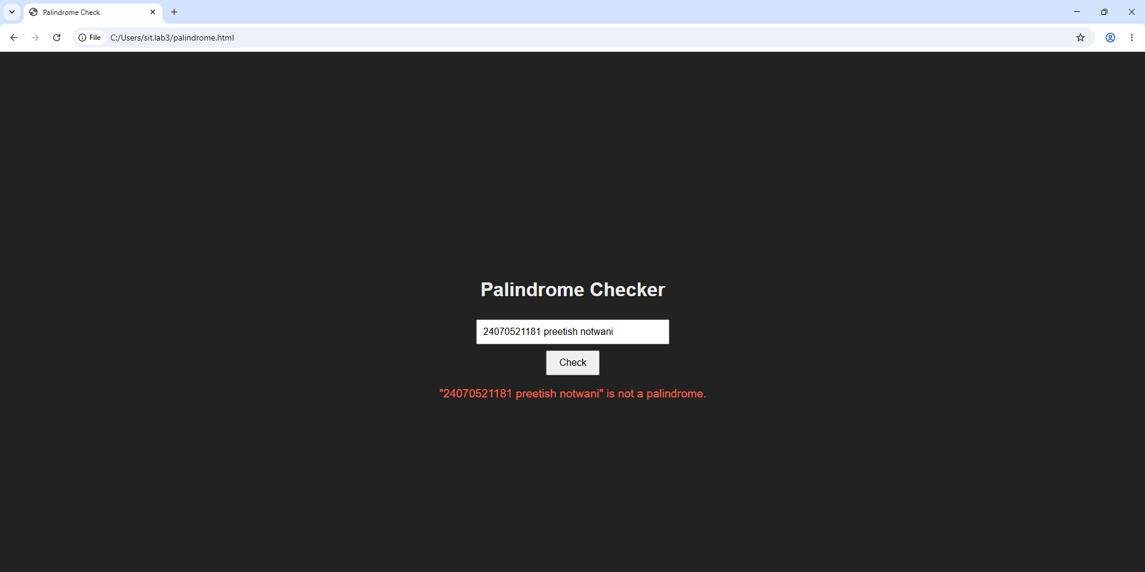
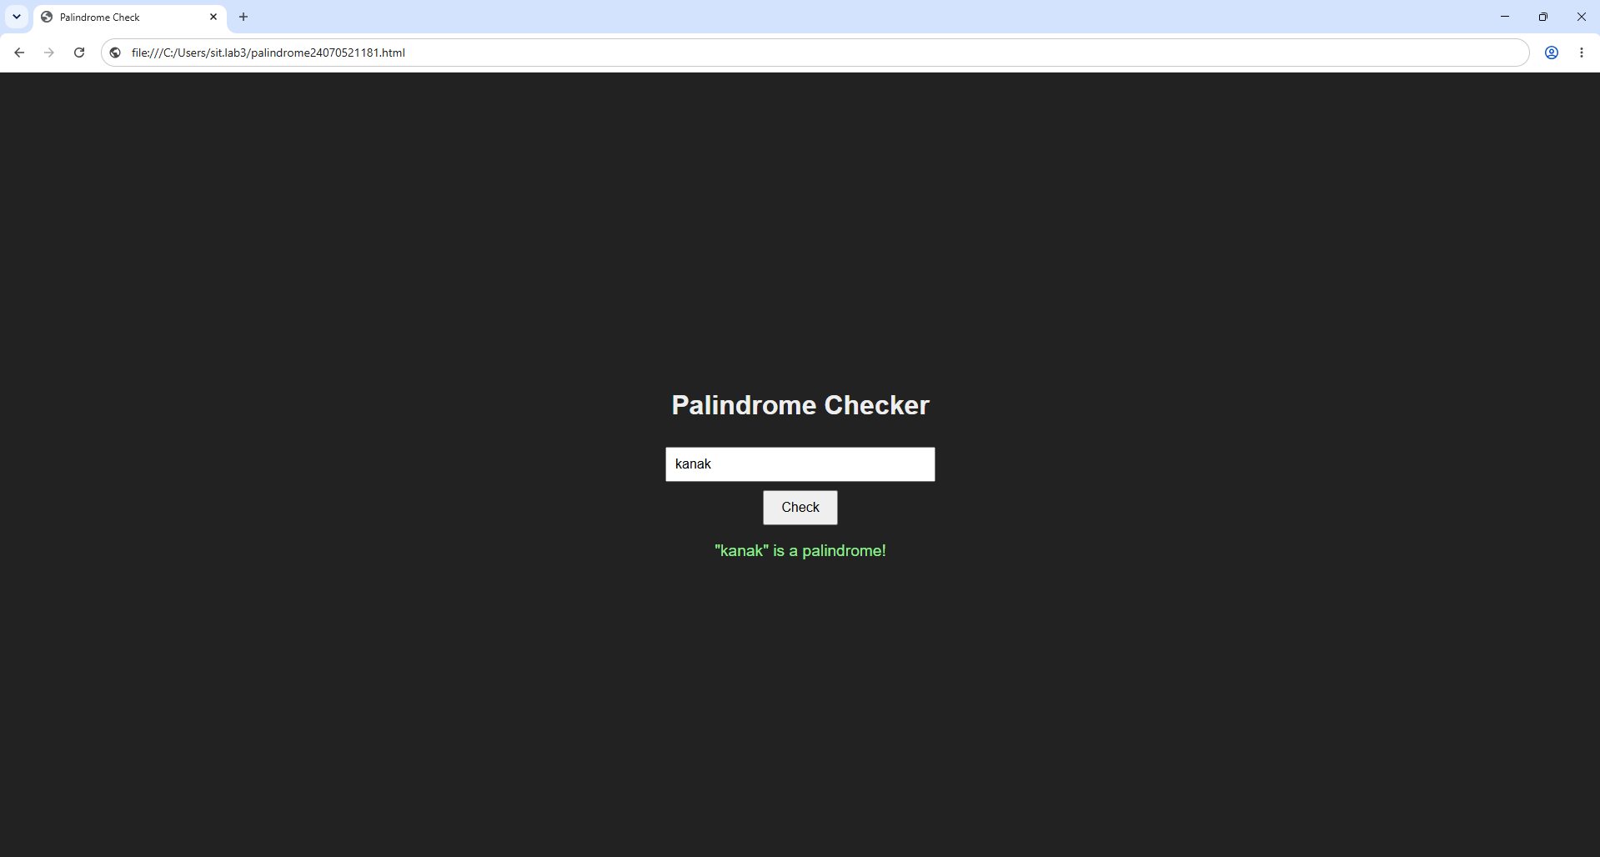

Case Study 04
Real-Time Case Study: ATM Card PIN Verification Using JavaScript Functions
Case Study An ATM system verifies whether a customer's PIN is a palindrome. If the PIN reads the same forward and backward, the bank displays a special security message. To implement this, create a function to reverse the entered PIN number and another function to check whether it is a palindrome. Use function declaration, function expression, arrow function, and demonstrate scope concepts
Software/Tools Used:- VScode , Web Browser
Case Study Code:-
<!DOCTYPE html>
<html>
<head>
<title>ATM PIN Verification</title>
<style>
/* Centers everything on the webpage */
body {
font-family: Arial, sans-serif;
background-color: #f5f6fa;
display: flex;
justify-content: center;
align-items: center;
height: 100vh;
margin: 0;
}

/* Clean panel layout for your practical */
.practical-panel {
background-color: #ffffff;
padding: 30px;
border-radius: 8px;
border: 1px solid #dcdde1;
box-shadow: 0 4px 10px rgba(0,0,0,0.05);
text-align: center;
}

/* Simple styling for the text input box */
input {
padding: 8px;
font-size: 16px;
border: 1px solid #718093;
border-radius: 4px;
width: 150px;
}

/* Simple styling for the operation buttons */
button {
padding: 8px 15px;
font-size: 14px;
cursor: pointer;
margin: 5px;
border: 1px solid #718093;
border-radius: 4px;
background-color: #f8f9fa;
}

button:active {
background-color: #dcdde1;
}

/* Output feedback paragraph */
#statusMessage {
font-weight: bold;
margin-top: 20px;
font-size: 18px;
color: #2f3640;
}
</style>
</head>
<body>

<div class="practical-panel">
<h2>ATM PIN VERIFICATION</h2>

<hr style="border: 0; border-top: 1px solid #dcdde1; margin-bottom: 20px;">

<!-- Form layout elements -->
<table cellpadding="8" style="margin: 0 auto;">
<tr>
<td><label>Enter PIN:</label></td>
<!-- CHANGED: type="text" is now type="password" to mask typing with dots -->
<td><input type="password" id="pinField" maxlength="6" placeholder="e.g. 1221"></td>
</tr>
<tr>
<td colspan="2">
<button onclick="verifyPin()">Verify PIN</button>
<button onclick="clearFields()">Reset</button>
</td>
</tr>
</table>

<!-- Output Display Area -->
<div id="statusMessage">Result: Awaiting Input...</div>
</div>

<script>
function verifyPin() {
var currentPin = document.getElementById("pinField").value;

if (currentPin === "") {
document.getElementById("statusMessage").innerText = "Result: Please enter a PIN first.";
return;
}

// Standard reversal method
var reversedPin = currentPin.split("").reverse().join("");

if (currentPin === reversedPin) {
document.getElementById("statusMessage").innerText = "Result: is a weak password! ";
} else {
document.getElementById("statusMessage").innerText = "Result: Verification Successful! ";
}
}

function clearFields() {
document.getElementById("pinField").value = "";
document.getElementById("statusMessage").innerText = "Result: Awaiting Input...";
}
</script>

</body>
</html>

Output:-
